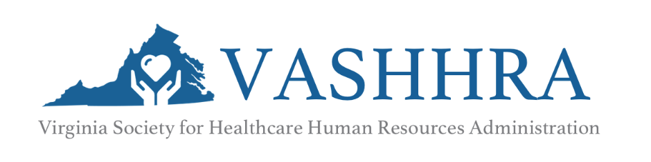

Agenda
Richmond/Tidewater Regional Meeting
11:00 AM – 12:30 PM, Wednesday, October 26, 2022
Webinar/Virtual Meeting

11:00AM – 11:05AM Welcome/Opening Remarks

11:05 AM – 12:05 PM Best Practices in Survey Reporting and Compensation Governance
Shannon Malone, Survey Manager and
Linette Allison, Managing Director from Gallagher
12:06pm -12:30pm Richmond/Tidewater Regional Meeting

